**UNIVERSITY OF MISSOURI- ST. LOUIS**

History 1076 Advanced Credit-The World Since 1300: Spring Semester 2025

**GATEWAY STEM HIGH SCHOOL**

Advanced Placement World History Modern: Semester 2 2025

**Instructor:** Josh Torres Wedding

**Classroom/Office:** 418 North Gateway STEM

**Office Hours**: Monday and Wednesday—9:00 AM to 10:00 AM

Tuesdays and Thursdays—7:30 AM-8:30 PM

**Email**: joshua.wedding@slps.org

**Website:** https://www.slps.org/Domain/7642

COURSE DESCRIPTION:

The purpose of the AP World History course is to develop a greater understanding of the evolution of global processes and contacts in different types of human societies. This understanding is advanced through a combination of selective content knowledge and appropriate analytical skills. This course will be centered around primary source document analysis, class discussion, and argumentative essay writing that uses evidence to support a thesis. The course highlights the nature of changes in global frameworks and their causes and consequences, as well as comparisons among major societies. It emphasizes relevant factual knowledge, leading interpretive issues, and skills in analyzing types of historical evidence.

For more information on the course, see the [College Board’s overview and course description.](https://apcentral.collegeboard.org/courses/ap-world-history)

The AP World History: Modern framework included in the course and exam description outlines distinct skills that students should practice throughout the year—skills that will help them learn to think and act like historians.

HISTORICAL THINKING SKILLS:

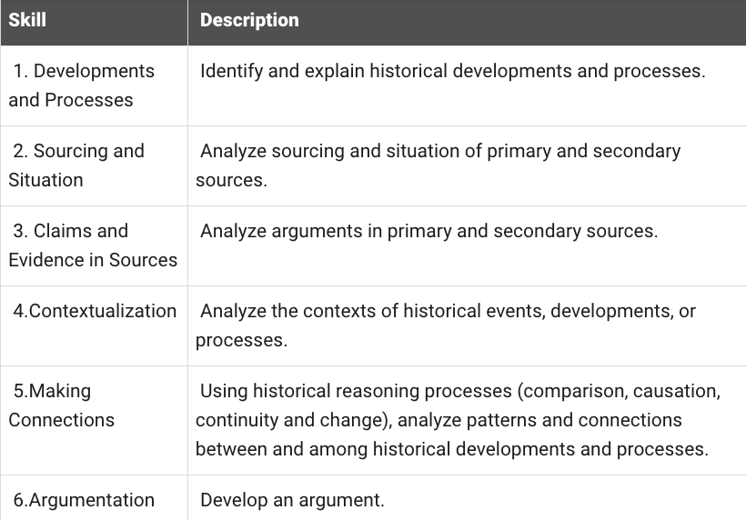

HISTORICAL REASONING PROCESSES:

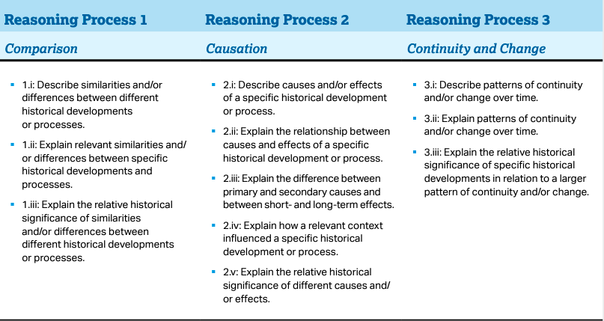

COURSE OBJECTIVES:

1. Master knowledge of world history
2. Effectively use tools of historiography
3. Apply and analyze skills using primary source documents and DBQs
4. Evaluate information and synthesize original thought
5. Understand the themes of Advanced Placement World History
6. Prepare for and perform successfully on the AP Exam

REQUIRED TEXT:

This class will have a required textbook, as well frequent handouts of primary and secondary sources.

AMSCO Publication. *World History Modern: Preparing for the Advanced Placement Examination*. Des Moines, IA: Perfect Learning Corp, 2019

ORGANIZATION OF THE COURSE: (*Continuing form first semester World History 1075*)

**Unit 5: Revolutions c. 1750-1900**

5.1 The Enlightenment

5.2 Nationalism and Revolutions

5.3 Industrial Revolution Begins

5.4 Industrialization Spreads

5.5 Technology of the Industrial Age

5.6 Industrialization: Government’s Role

5.7 Economic Developments & Innovations in the Industrial Age

5.8 Reactions to the Industrial Economy

5.9 Society and the Industrial Age

5.10 Continuity and Change in the Industrial Age

**Unit 6: Consequences of Industrialization c. 1750-1900**

6.1 Rationales for Imperialism

6.2 State Expansion

6.3 Indigenous Responses to State Expansion

6.4 Global Economic Development

6.5 Economic Imperialism

6.6 Causes of Migration in an Interconnected World

6.7 Effects of Migration

6.8 Causation in the Imperial Age

**Unit 7: Global Conflict c. 1900 to the present**

**7**.1 Shifting Power

7.2 Causes of World War I

7.3 Conducting World War I

7.4 Economy in the Interwar Period

7.5 Unresolved Tensions after World War I

7.6 Causes of World War II

7.7 Conducting World War II

7.8 Mass Atrocities

7.9 Causation in Global Conflict

**Unit 8: Cold War and Decolonization c. 1900 to the present**

8.1 Setting the stage for the Cold War and Decolonization

8.2 The Cold War

8.3 Effects of the Cold War

8.4 Spread of Communism

8.5 Decolonization

8.6 Newly Independent States

8.7 Global Resistance to Established Power Structures

8.8 End of the Cold War

8.9 Causation in the Age of the Cold War & Decolonization

**Unit 9: Globalization c. 1900 to the present**

9.1 Advances in Technology and Exchange

9.2 Technological Advances and Limitations: Disease

9.3 Technological Advances: Debates about the Environment

9.4 Economics in the Global Age

9.5 Calls for Reform and Responses

9.6 Globalized Culture

9.7 Resistance to Globalization

9.8 Institutions Developing in a Globalized World

9.9 Continuity and Change in a Globalized World

AP WORLD HISTORY THEMES

**THEME 1: HUMANS AND THE ENVIRONMENT (ENV)** The environment shapes human societies, and as populations grow and change, these populations in turn shape their environments.

**THEME 2: CULTURAL DEVELOPMENTS AND INTERACTIONS (CDI**) The development of ideas, beliefs, and religions illustrates how groups in society view themselves, and the interactions of societies and their beliefs often have political, social, and cultural implications.

**THEME 3: GOVERNANCE (GOV)** A variety of internal and external factors contribute to state formation, expansion, and decline. Governments maintain order through a variety of administrative institutions, policies, and procedures, and governments obtain, retain, and exercise power in different ways and for different purposes.

**THEME 4: ECONOMIC SYSTEMS (ECN)** As societies develop, they affect and are affected by the ways that they produce, exchange, and consume goods and services.

**THEME 5: SOCIAL INTERACTIONS AND ORGANIZATION (SIO)** The process by which societies group their members and the norms that govern the interactions between these groups and between individuals influence political, economic, and cultural institutions and organization.

**THEME 6: TECHNOLOGY AND INNOVATION (TEC)** Human adaptation and innovation have resulted in increased efficiency, comfort, and security, and technological advances have shaped human development and interactions with both intended and unintended consequences

ASSIGNMENTS:

Weekly chapter readings will be assigned from both textbooks. Additional homework and class work will consist of primary source document analysis and essay writing. Students will also be expected to engage with a variety of media for assignments, including Heimler’s History videos and Freemen-pedia. Links to various resources can be found on instructor’s website, under the AP World Resources link.

EMAIL PROTOCOL:

On the “Subject” line: Student’s last name--a short description of the subject of the email. Students may also use the Remind app to contact the instructor, after joining the course via the app.

ACCESS AND DISABILITY:

Students requiring special accommodations should contact Gateway STEM Special Education Department or the Counseling Department to document their disability and determine what accommodations will be provided. Once they have this information, they should contact me.

GRADING:

Grade calculation:

40% formative assessments: classwork, homework, etc.

60% summative assessments: quizzes, exams, major projects, etc.

Late work will only be accepted until the end of the current unit, for reduced credit. Students may retake assignments if they are not happy with the grade received. However, make up assignments must be done outside of class time.

Students will receive numerical grades on all assignments ranging from 0-100. Numerical grades can be translated into letter grades according to the following:

A = 90-100 B = 80-89 C = 70-79 D = 60-69 F = 0-59

**If the student’s semester grade is 70 or higher, they have the opportunity to receive three college credit hours from the University of Missouri-St. Louis, Advanced Credit Program. St. Louis Public Schools will pay for the credits if the student receives an 80% or higher.**

AP WORLD HISTORYMODERN EXAM:

The exam is 3 hours and 15 minutes long and students are required to answer

-Multiple-Choice | 55 Questions | 55 Minutes | 40% of Exam Score

-Short Answer | 3 Questions | 40 Minutes | 20% of Exam Score

-Document-Based | 1 question | 60 Minutes | 25% of Exam Score

-Long Essay | 1 question | 15% of Exam Score | 40 minutes

